**Assignment 5 – INVENTORY MANAGEMENT AND DATABASE CONNECTION**

**a. Business area:**

The chosen area for which we want to build our inventory management system is a retail business for electronic goods. Electronic goods retailer is one who sells electronic items like mobile phone, laptops, etc.

**b. Introduction of business operation**

Our client is into management of the electronic goods that they get from the wholesalers, i.e. to store them in their physical warehouse, to keep a track of them, as to how much is sold and how much is left. In order to automate this inventory management for our client we have come up with inventory management system which helps our client in viewing all the items in the inventory, searching the inventory by product details like productid, product, cost and manufacturers, inserting a new record to the inventory, updating the inventory and deleting from it.

**c. identify IMS features (problem analysis)**

1. Add / insert into inventory system

2. View the entire inventory

3. Sort the inventory by product ID, product, cost and manufacturers.

4. Update the inventory

5. Delete the inventory.

**d. collect features/functions of this IMS (Requirements elicitation, SW specification)**

Features collected from the requirements documents and discussions.

e. design high and/or low level // e.g. UML, flow chart etc.

Flow Chart:

For Inserting Product details into IMS:

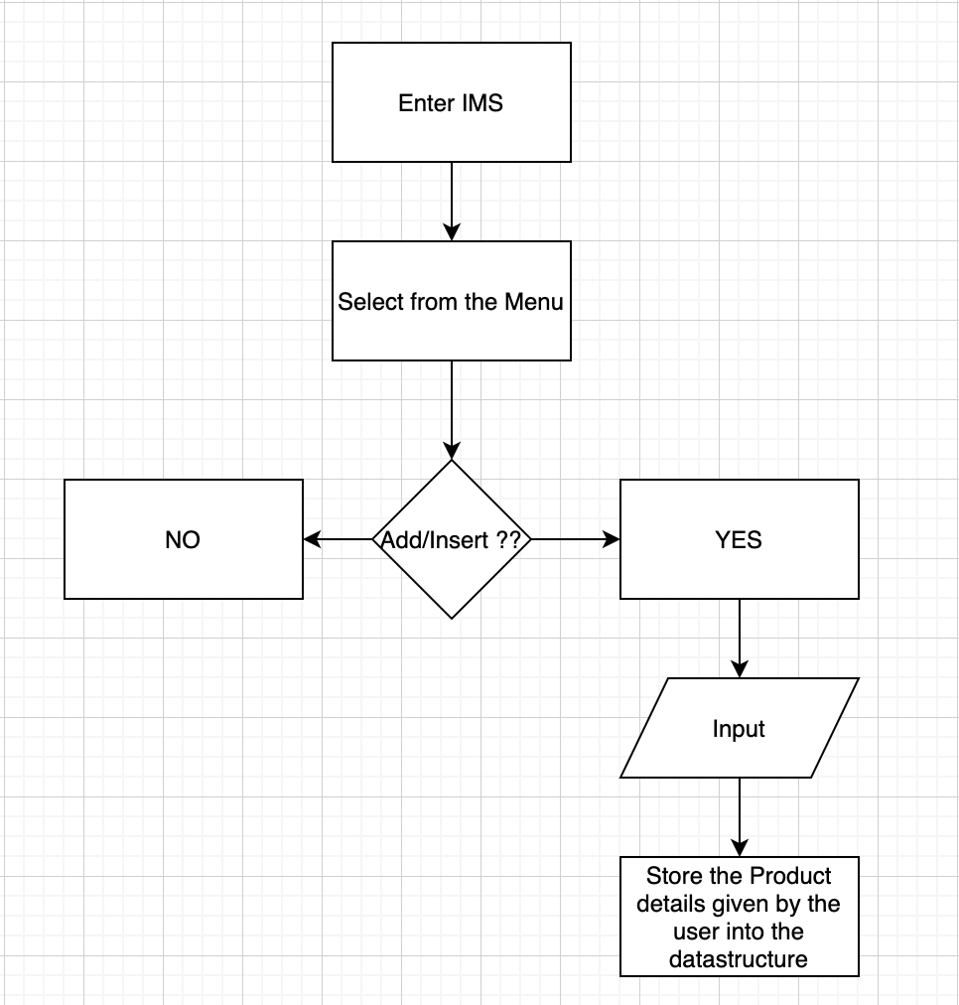

For Viewing Product details in the IMS:

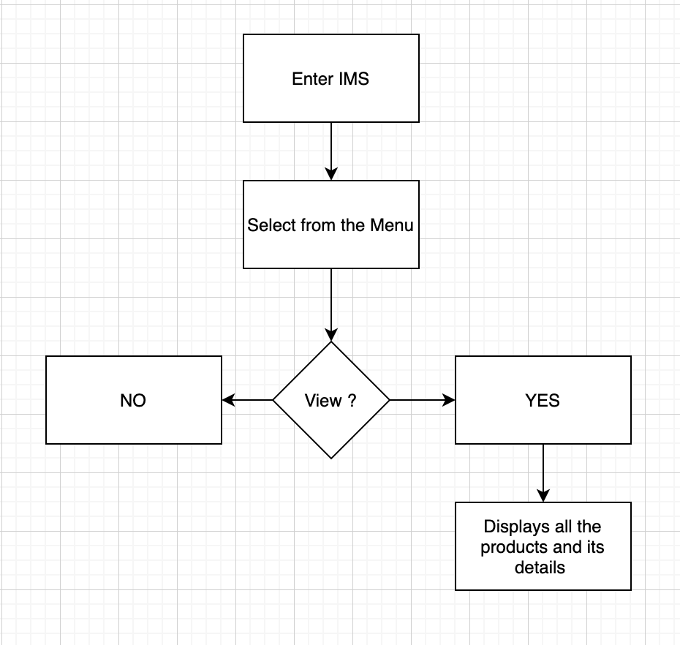

For searching Product details in the IMS:

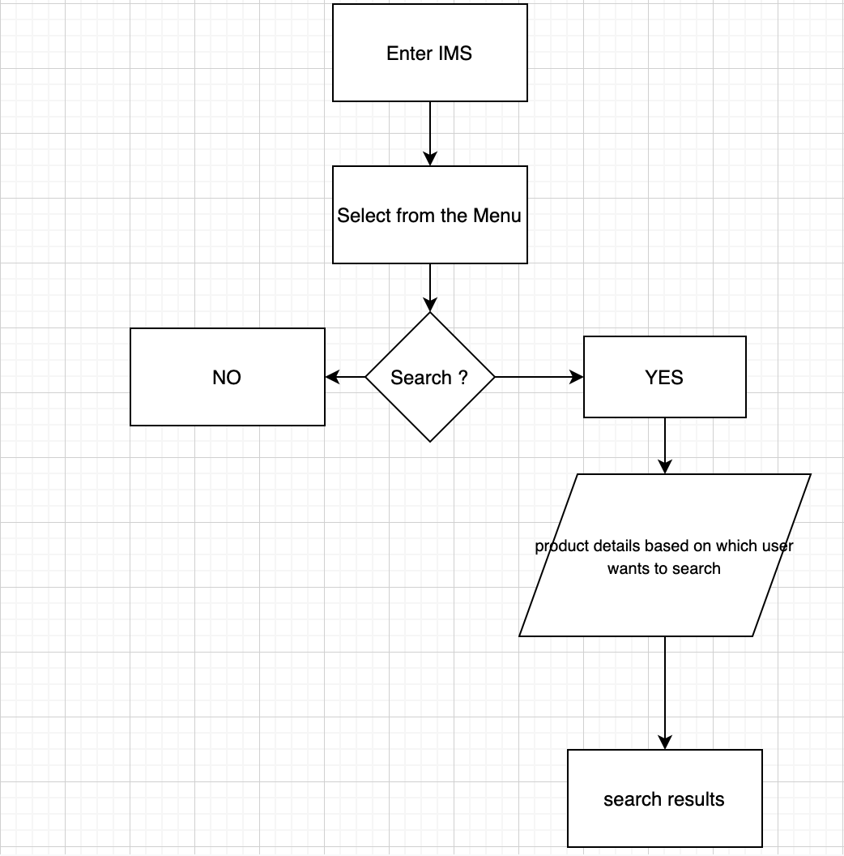

For update Product details in the IMS:

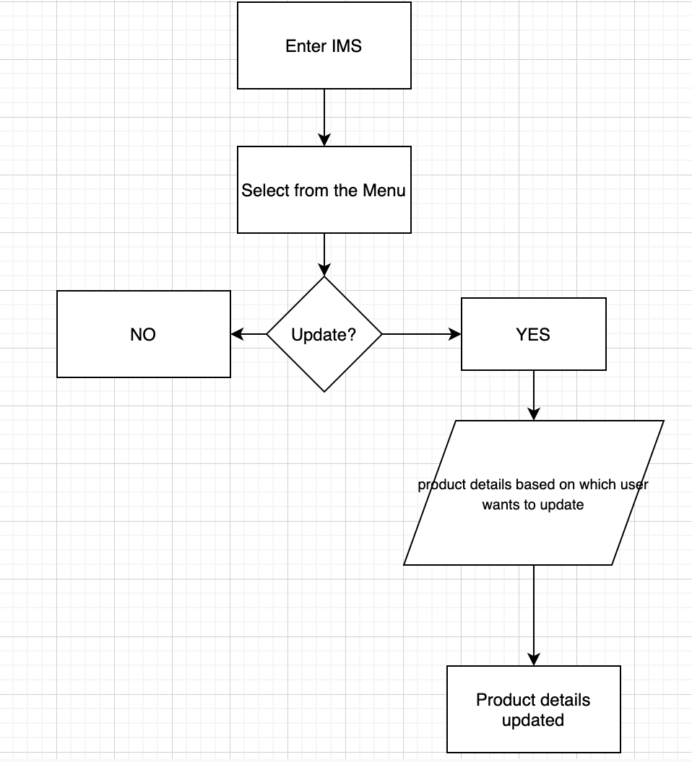

For delete Product details in the IMS:

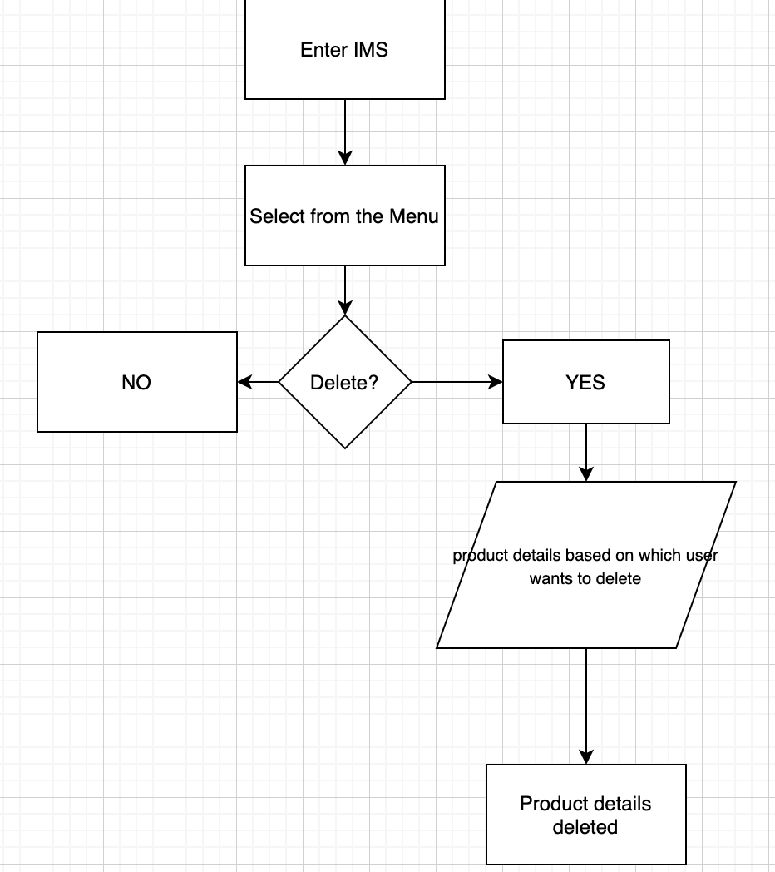

**f. DB connection**

DB Connection steps:

**Import JDBC packages:**

Import the required package,

import java.sql.Connection;

import java.sql.DriverManager;

import java.sql.Statement;

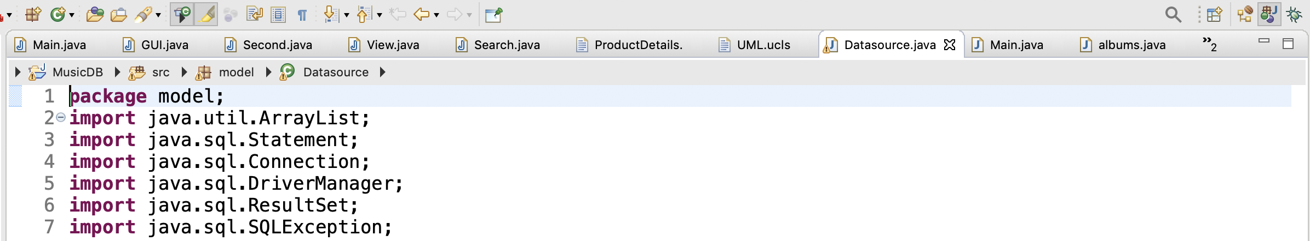

**Load and register the JDBC driver:** Since JDBC 4 explicitly registering the driver is optional, we just need to vendor’s Jar in the class path, and then JDBC driver can detect and load the driver automatically.

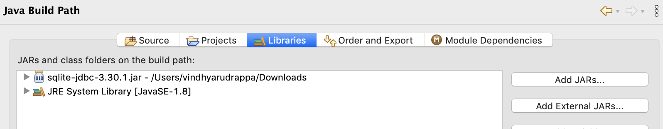

**Open a connection to the database:** In our application we have created A separate function inside datasource.java class in order to call open() wherever necessary.

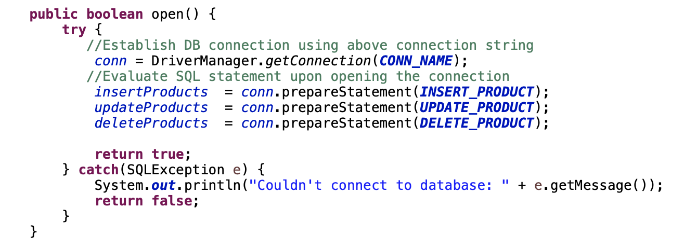

**Create String constants to hold connection and query related string constant:**

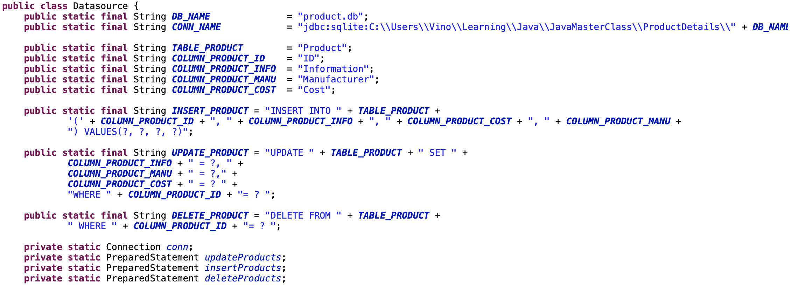

**Create a statement object to perform a query:**We have created different functions for different operations like select, update, insert, delete so that they can be calledwithin respective modules of our application.

**queryProducts()**

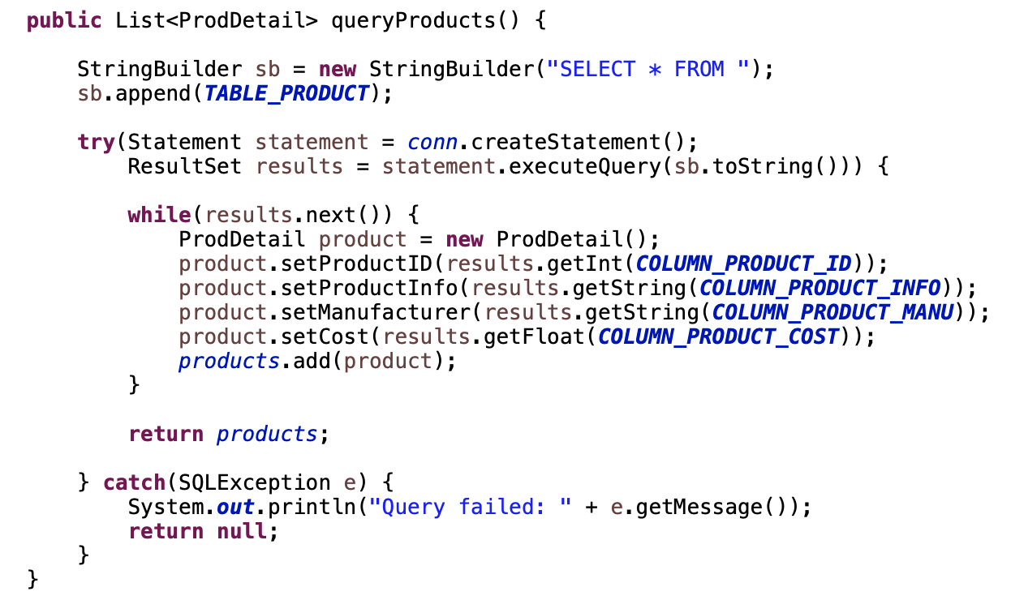

This function will query the database using select statement to display all the products in the table.

**UpdateProducts():**

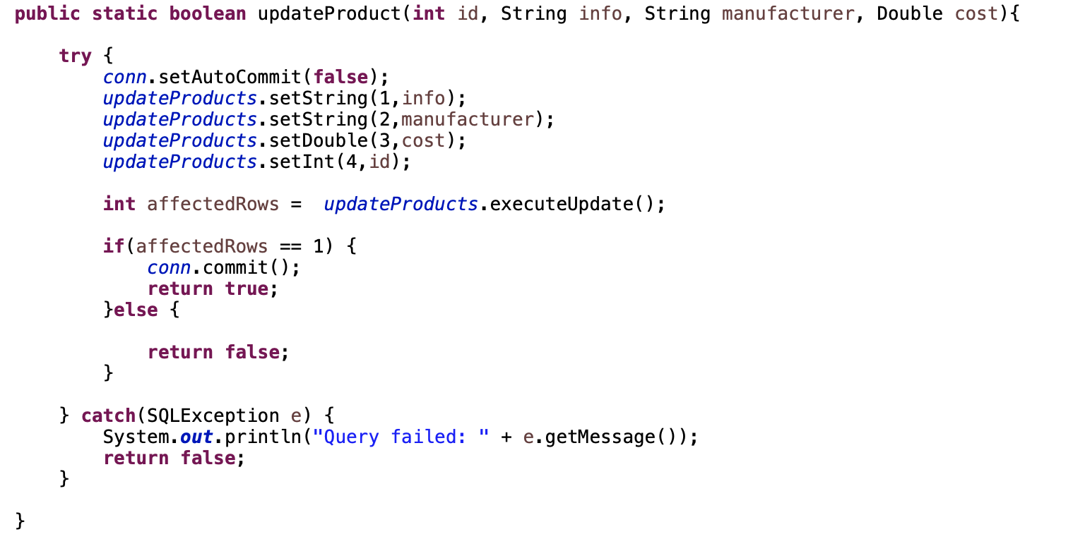

This query will update the products in the table using update query using the inputs given by user.

insertProducts()

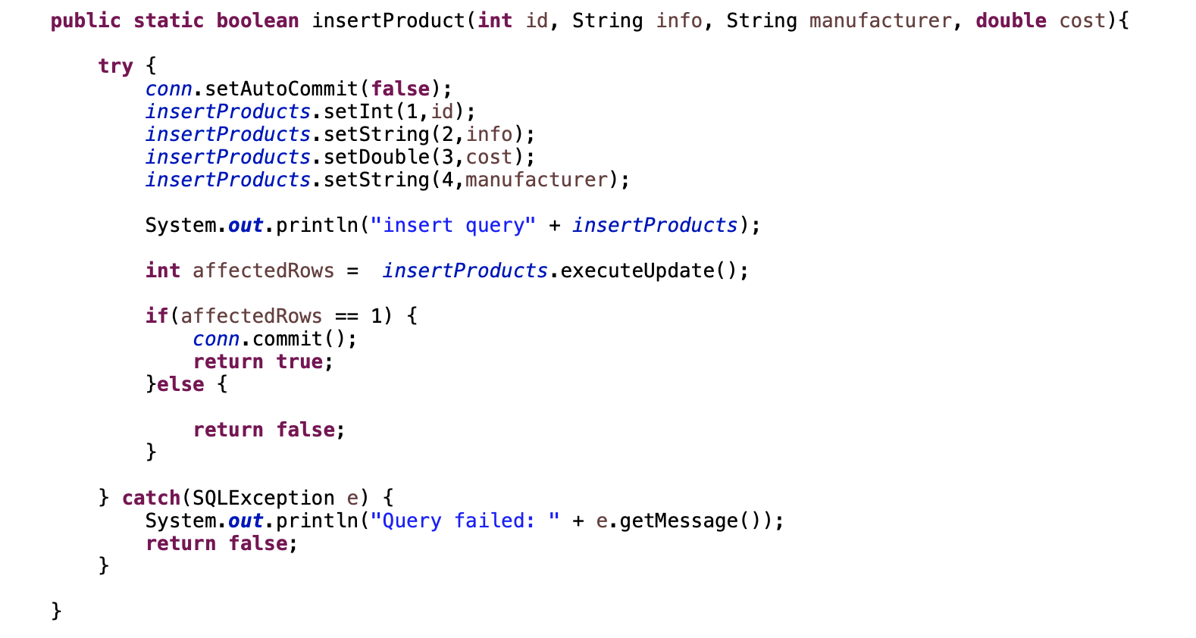

Used to insert the products into table using the user inputs.

**deleteProducts()**

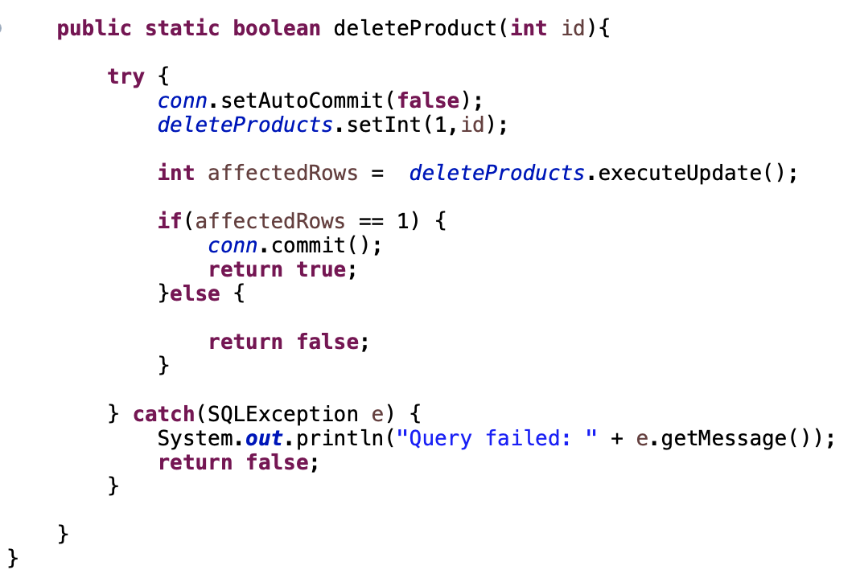

Delete the products based on the product ID given by the user.

**Execute the statement object and return a query result set:**

We are holding the result set of select query inside an array list using that in the appropriate places.

**try**(Statement statement = *conn*.createStatement();

ResultSet results = statement.executeQuery(sb.toString())) {

**while**(results.next()) {

ProdDetail product = **new** ProdDetail();

product.setProductID(results.getInt(***COLUMN_PRODUCT_ID***));

product.setProductInfo(results.getString(***COLUMN_PRODUCT_INFO***));

product.setManufacturer(results.getString(***COLUMN_PRODUCT_MANU***));

product.setCost(results.getFloat(***COLUMN_PRODUCT_COST***));

*products*.add(product);

}

**return** *products*;

} **catch**(SQLException e) {

System.***out***.println("Query failed: " + e.getMessage());

**return** **null**;

}

**Close the connection:**

**public** **void** close() {

**try** {

**if**(*conn* != **null**) {

*conn*.close();

}

} **catch**(SQLException e) {

System.***out***.println("Couldn't close connection: " + e.getMessage());

}

}

We are closing the connection here using the above close().

**g. Gantt chart - Project scheduling**

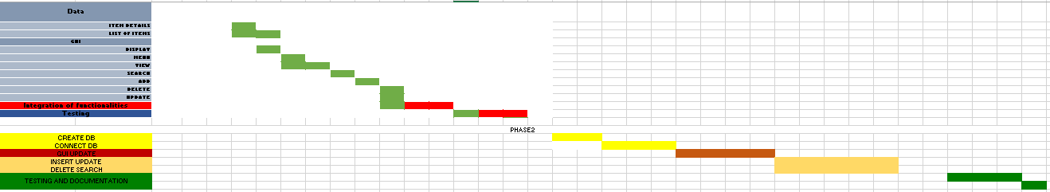

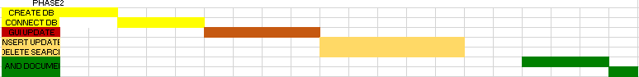

**h. Inventory Management System**

**Menu**

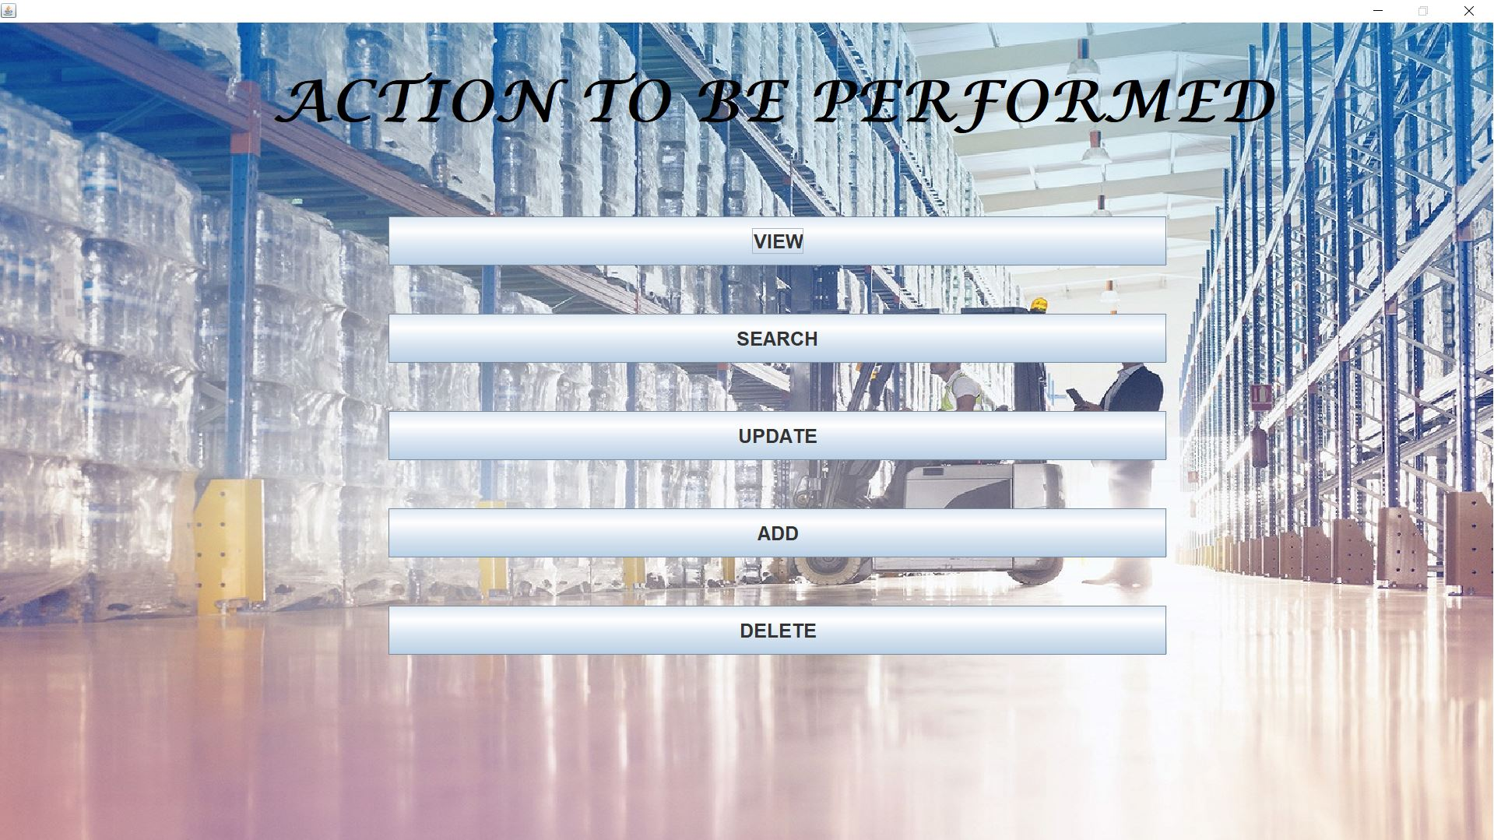

**Database**

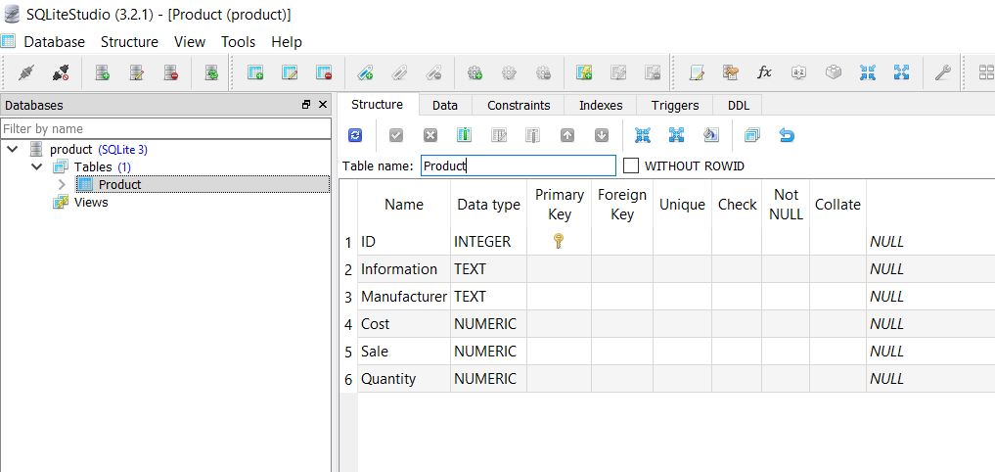

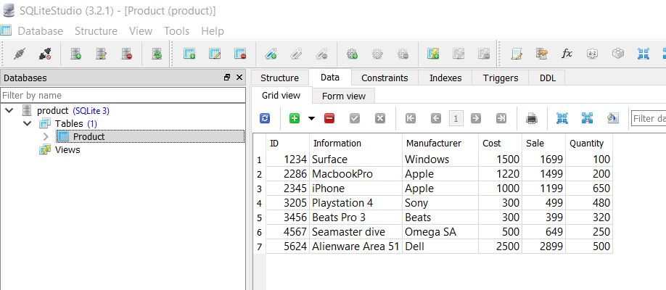

**ADD**

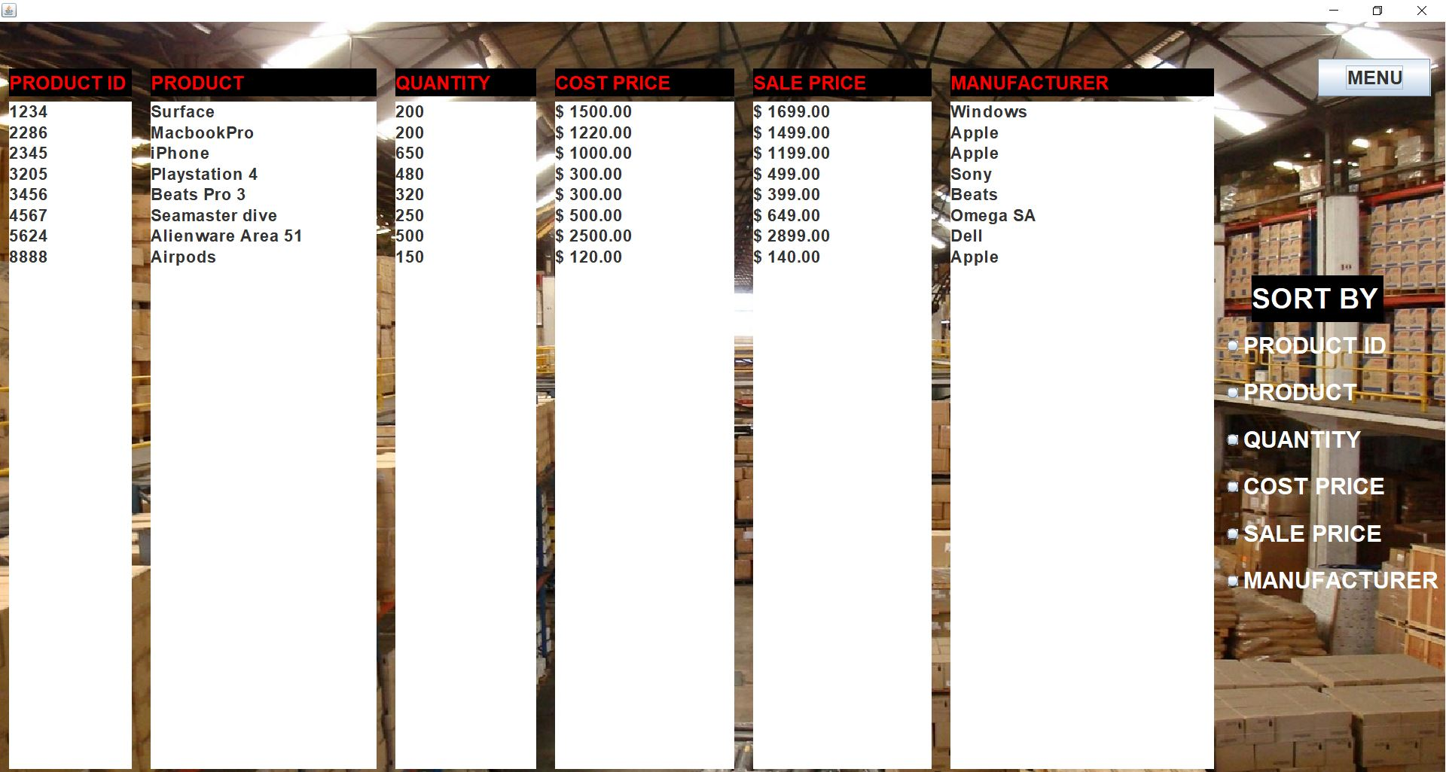

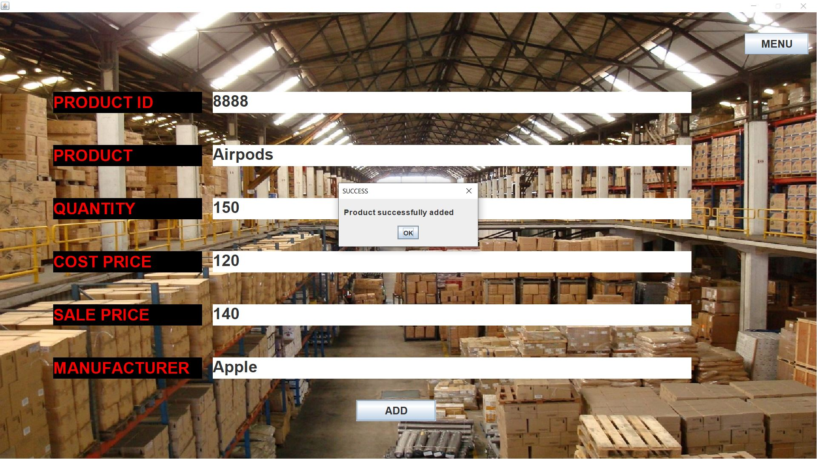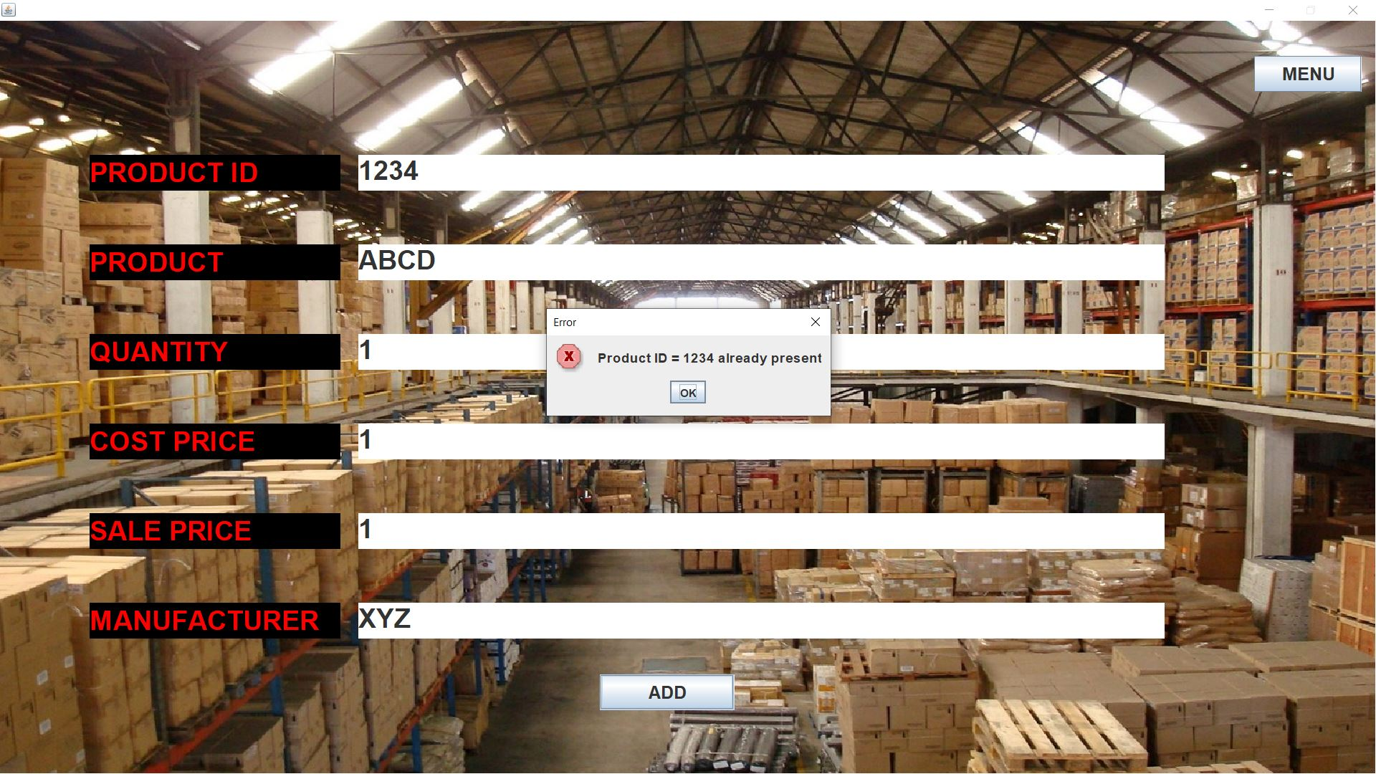

**DELETE**

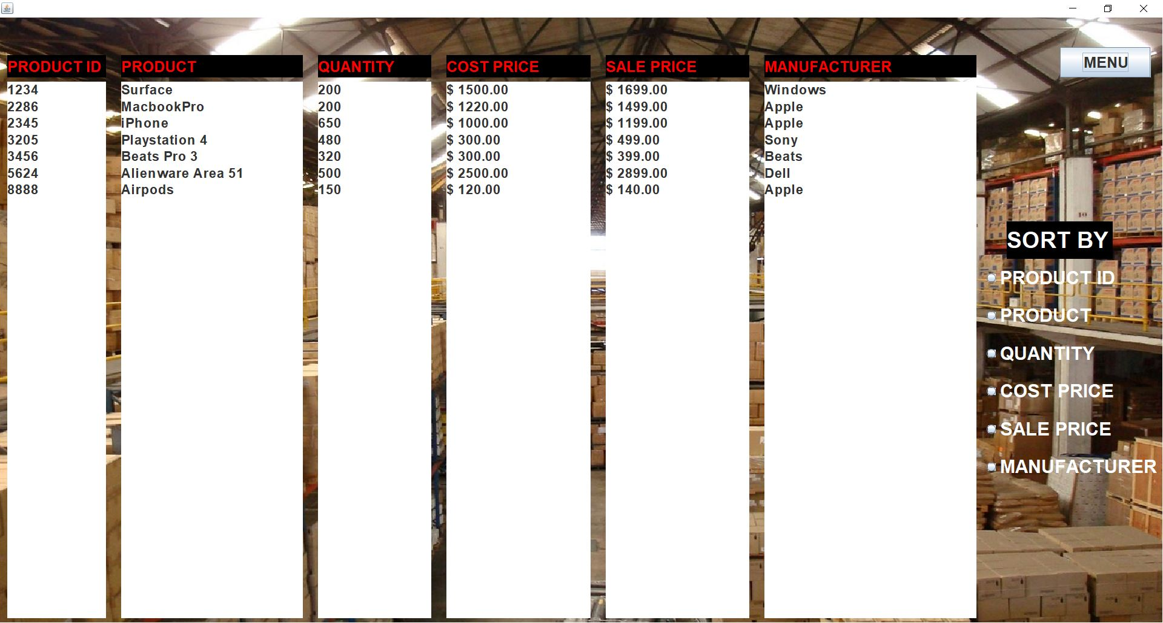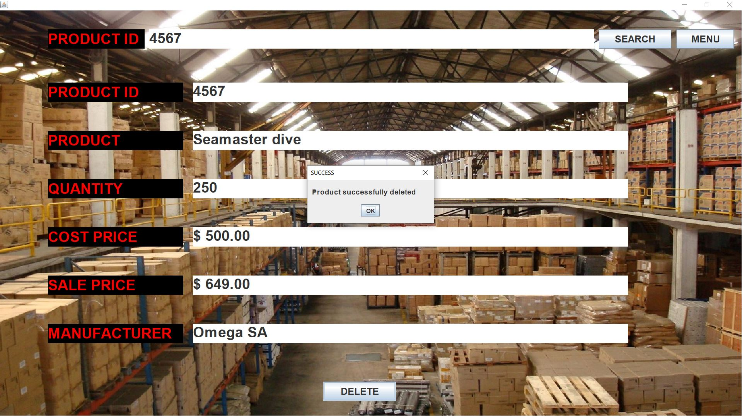

**SEARCH**

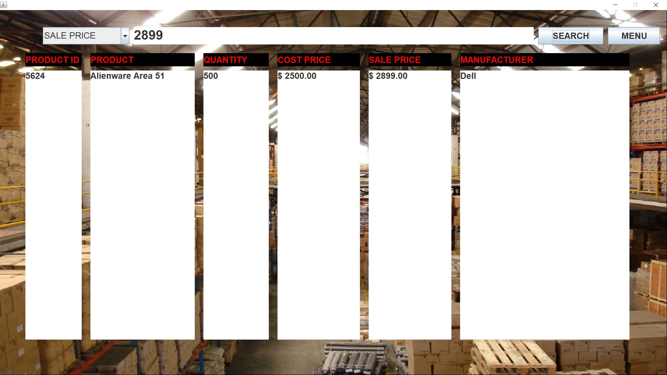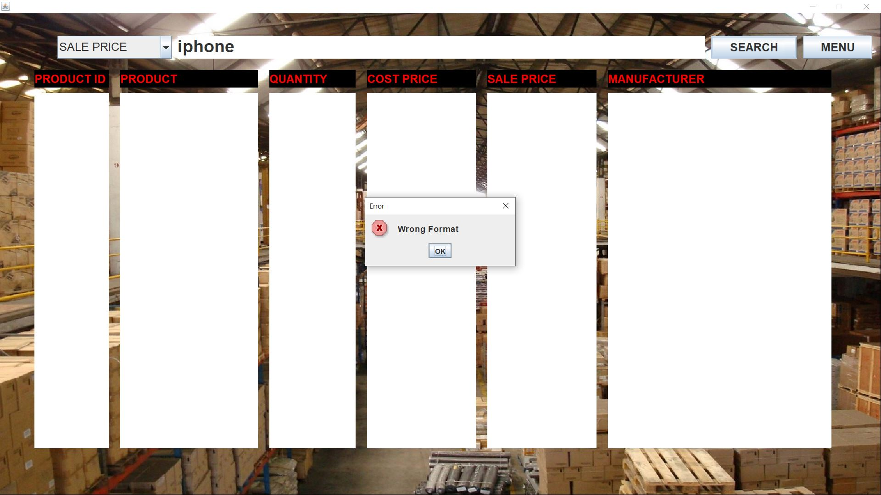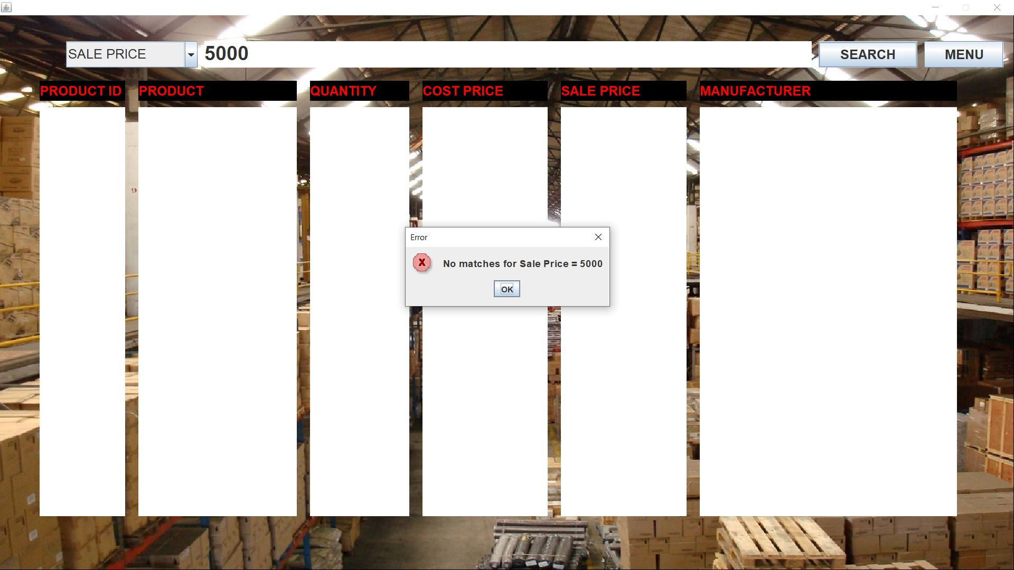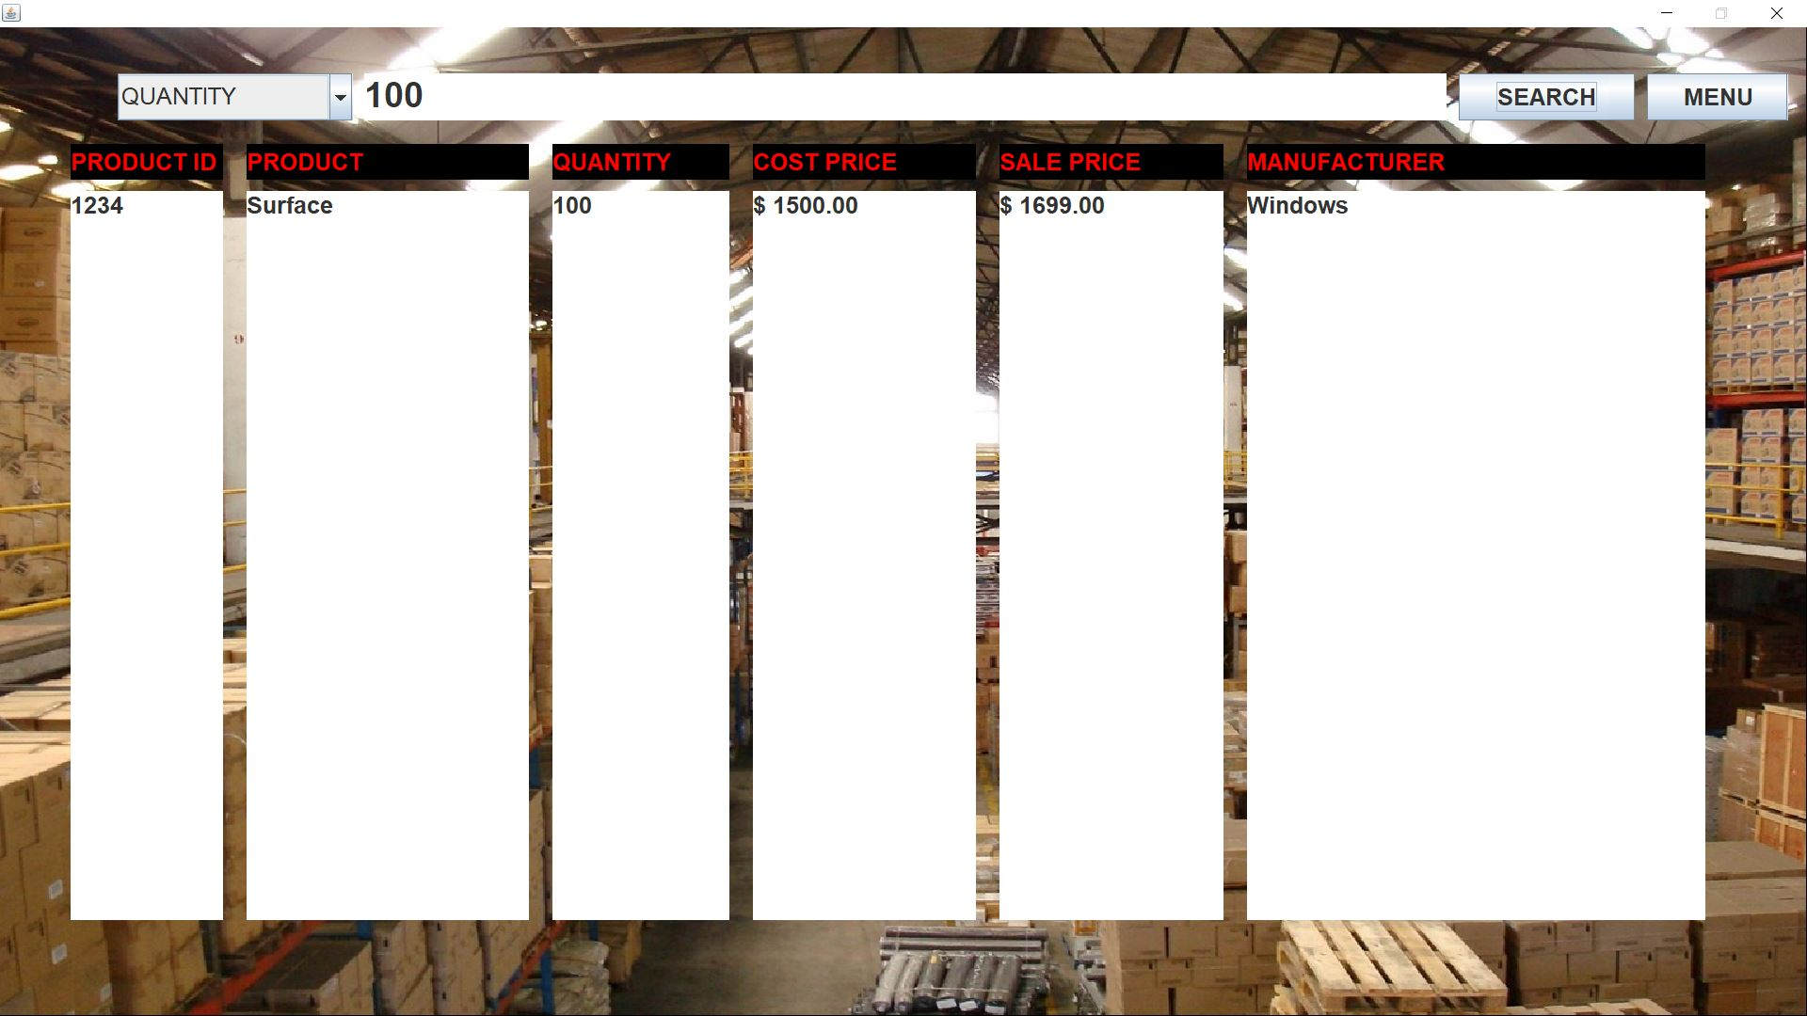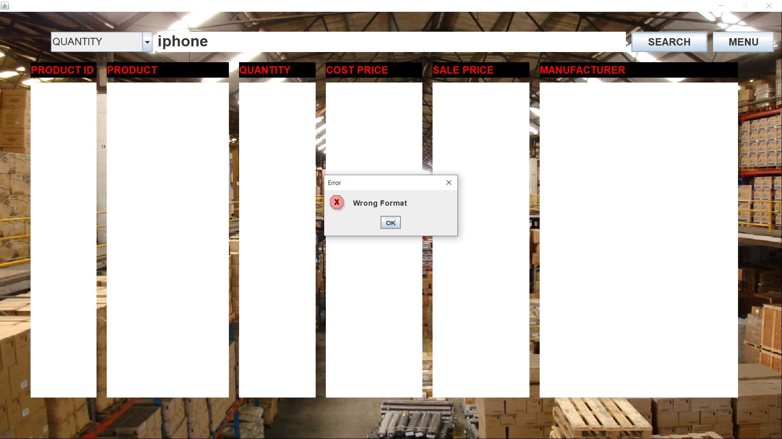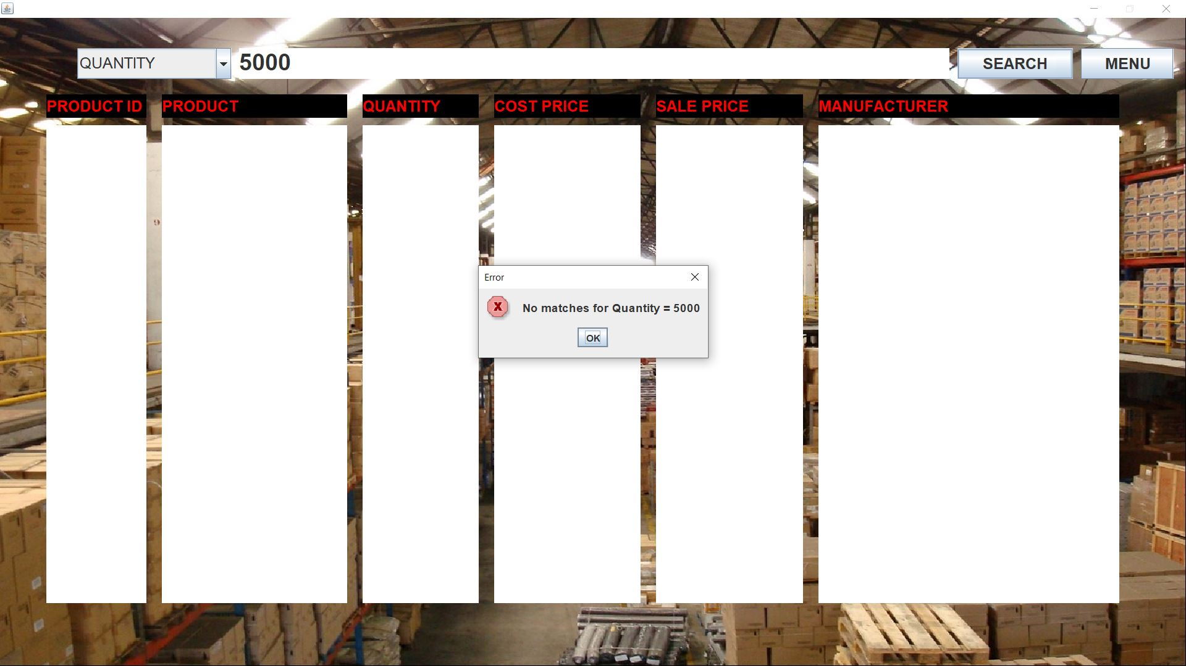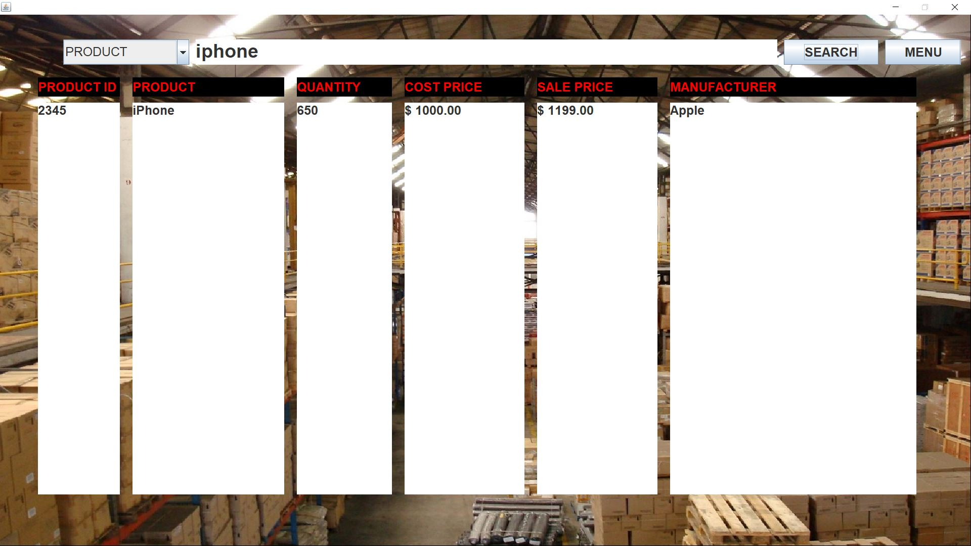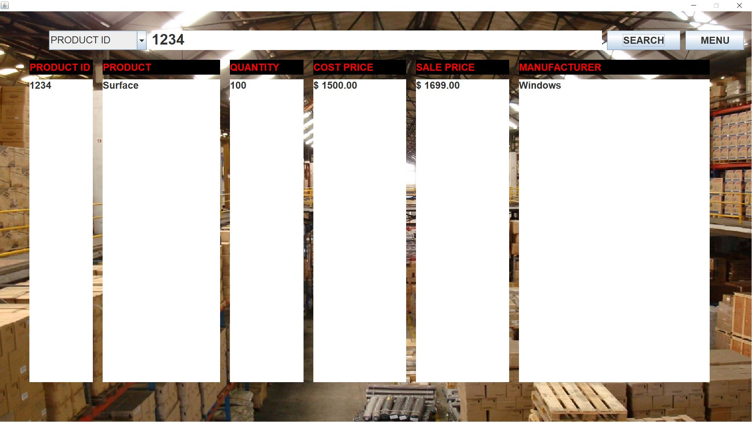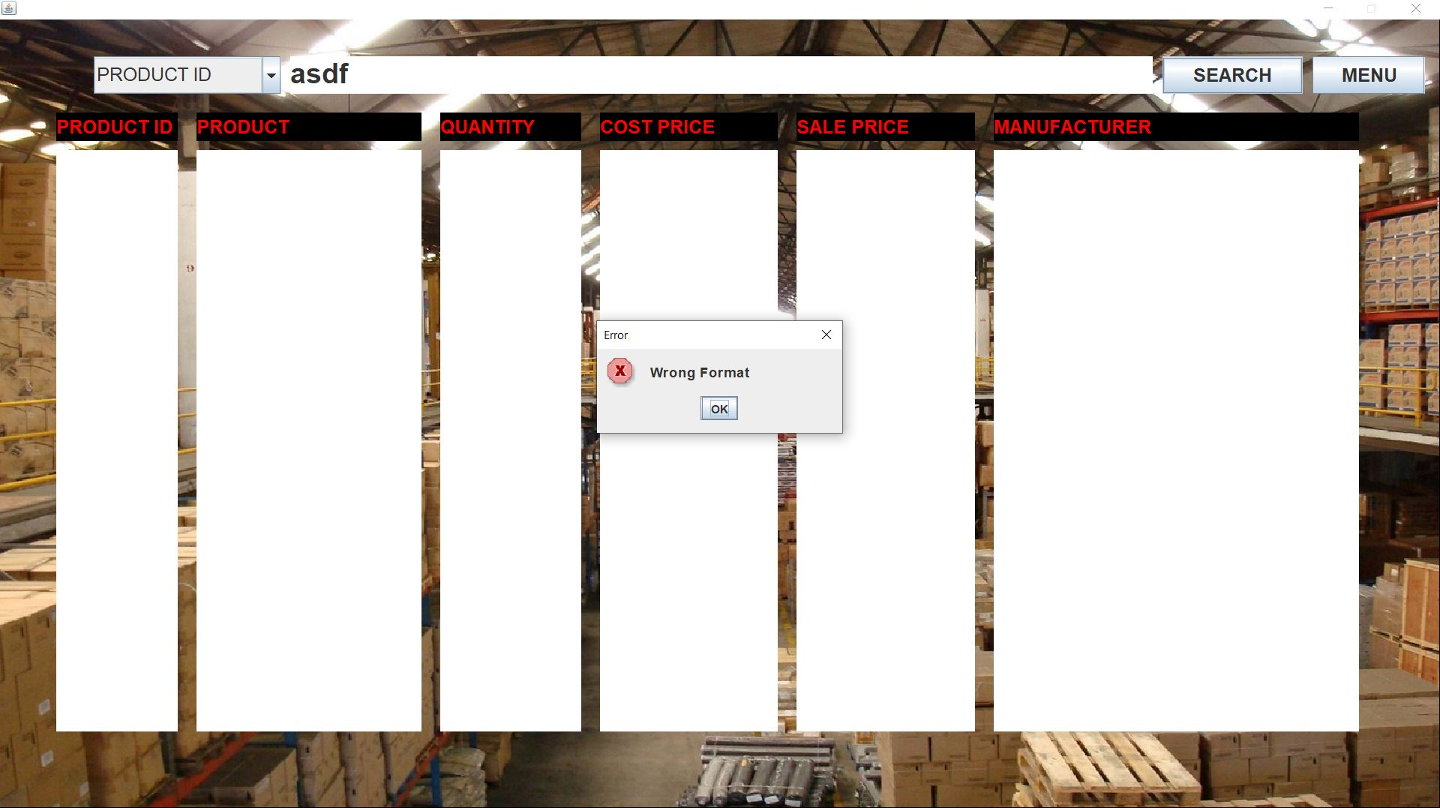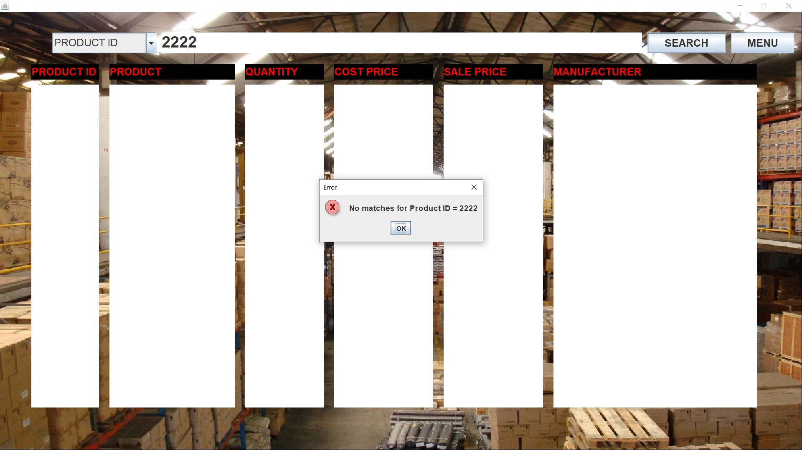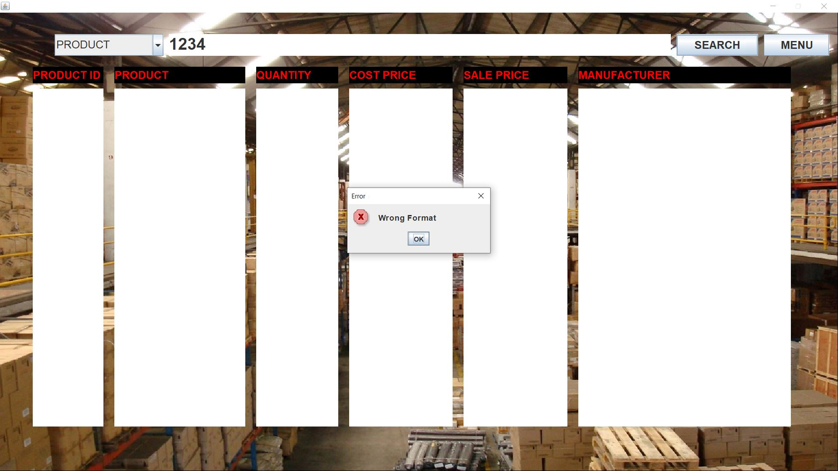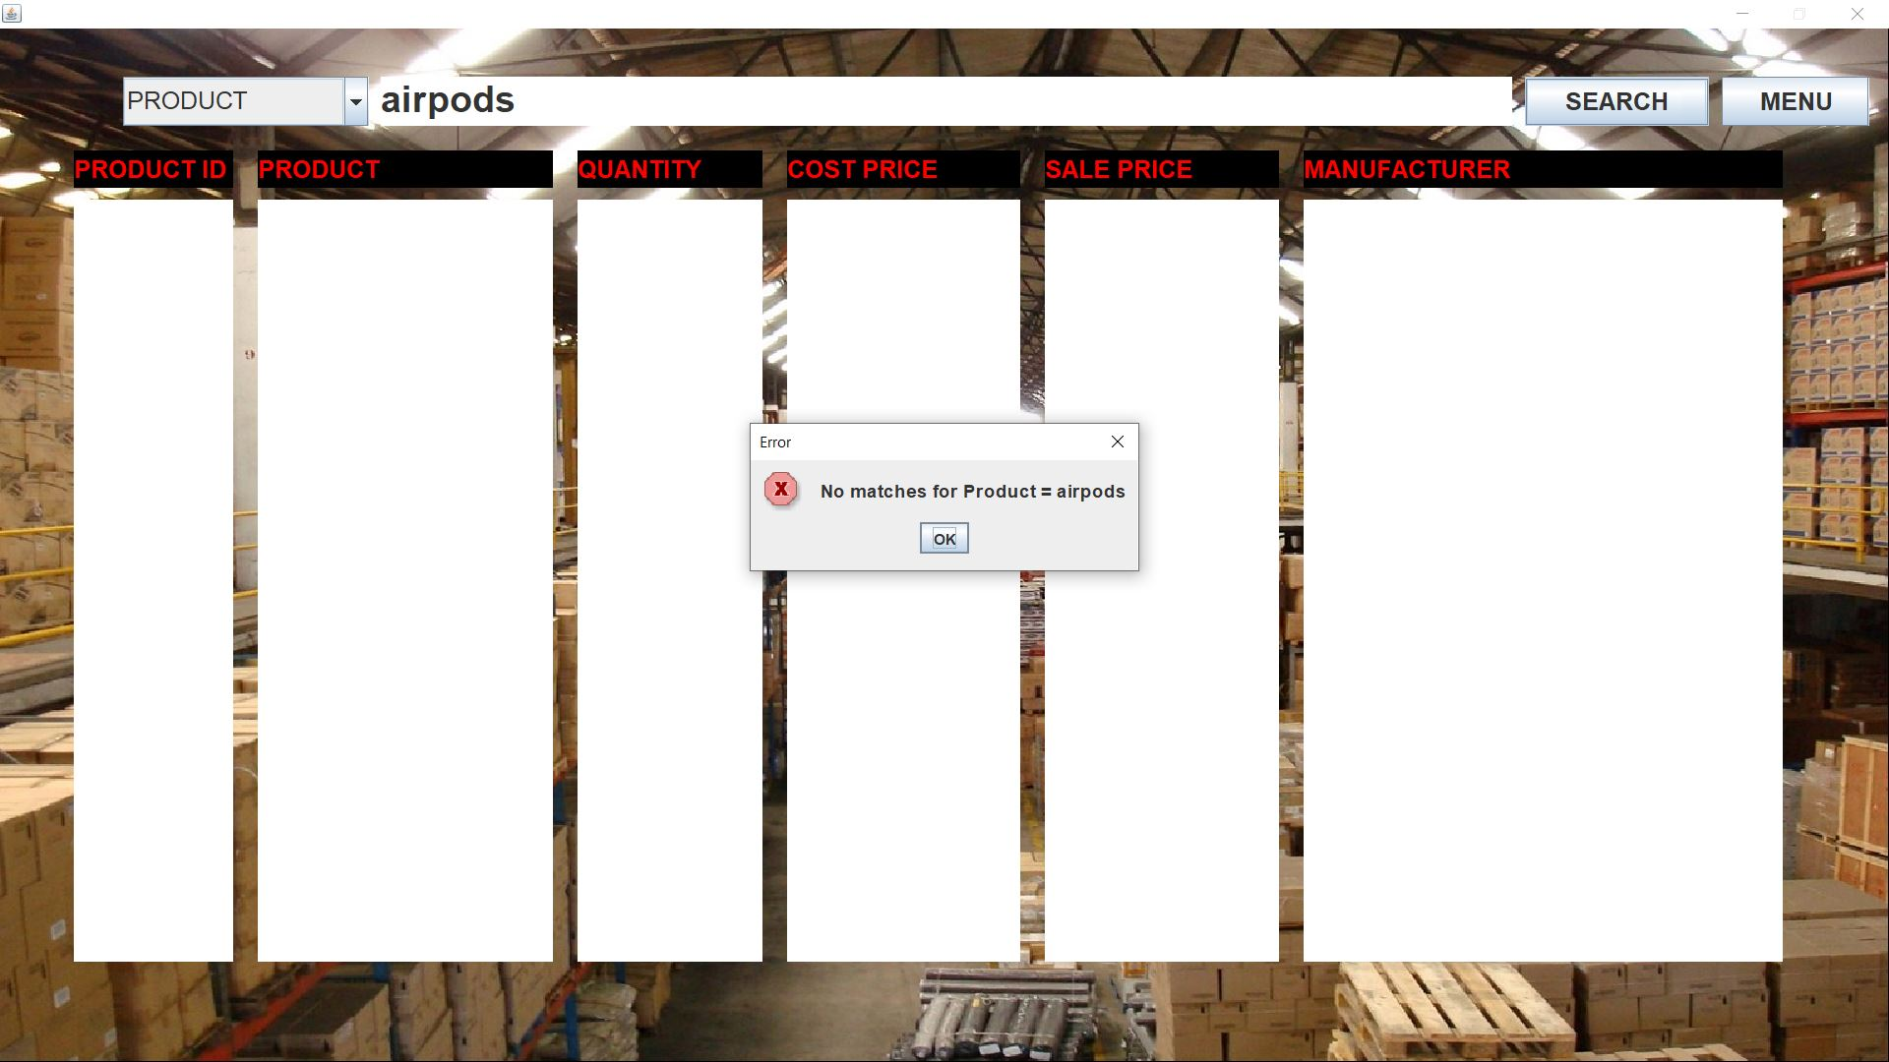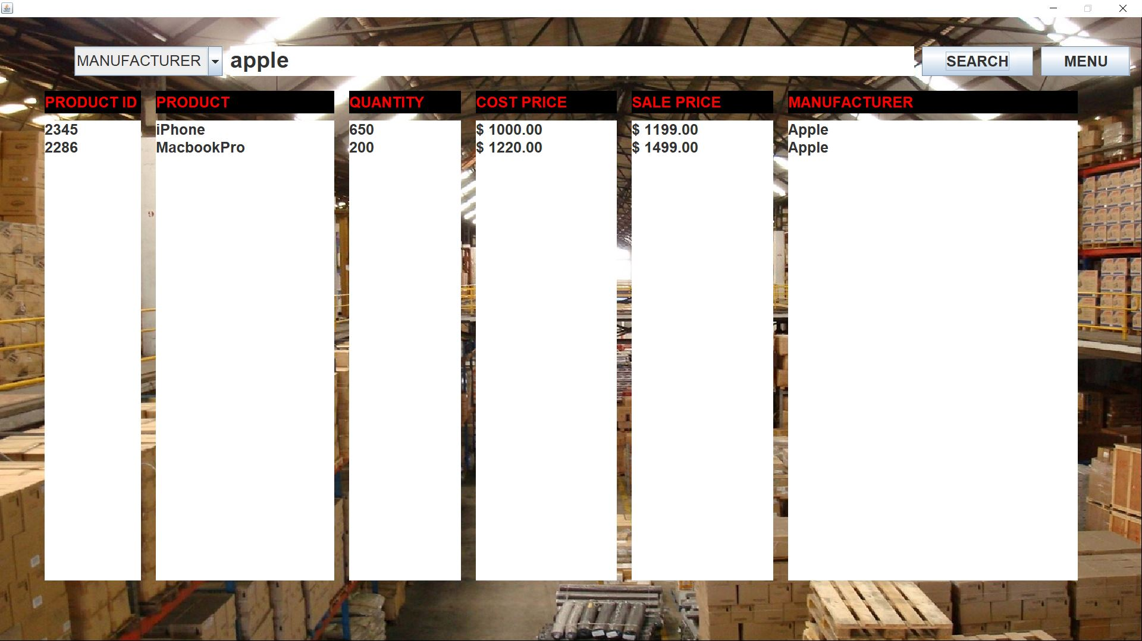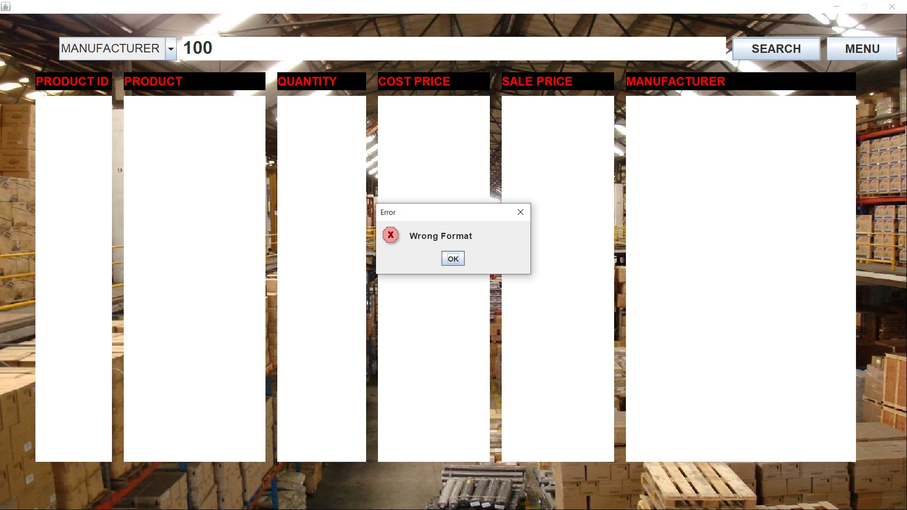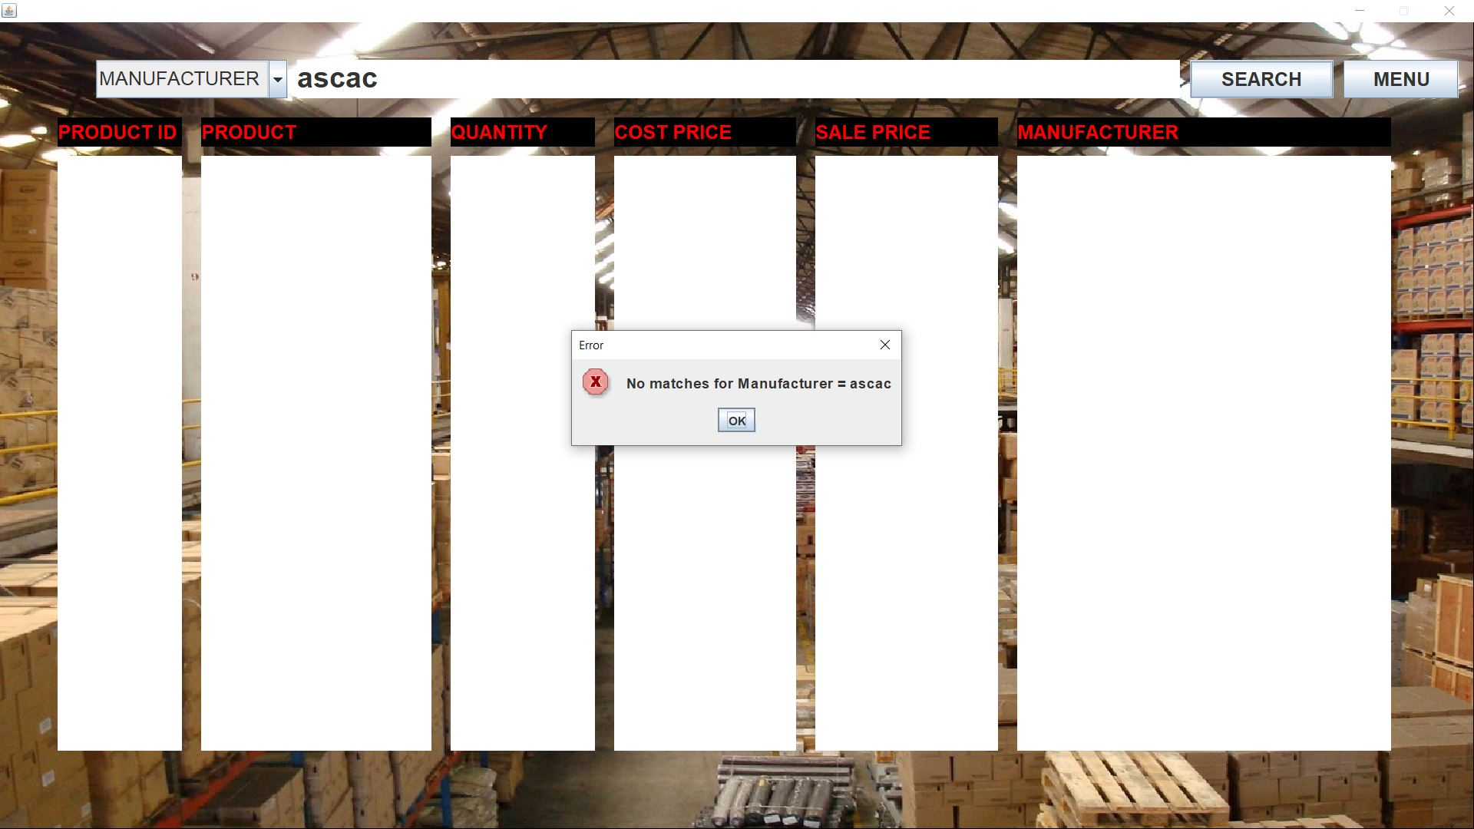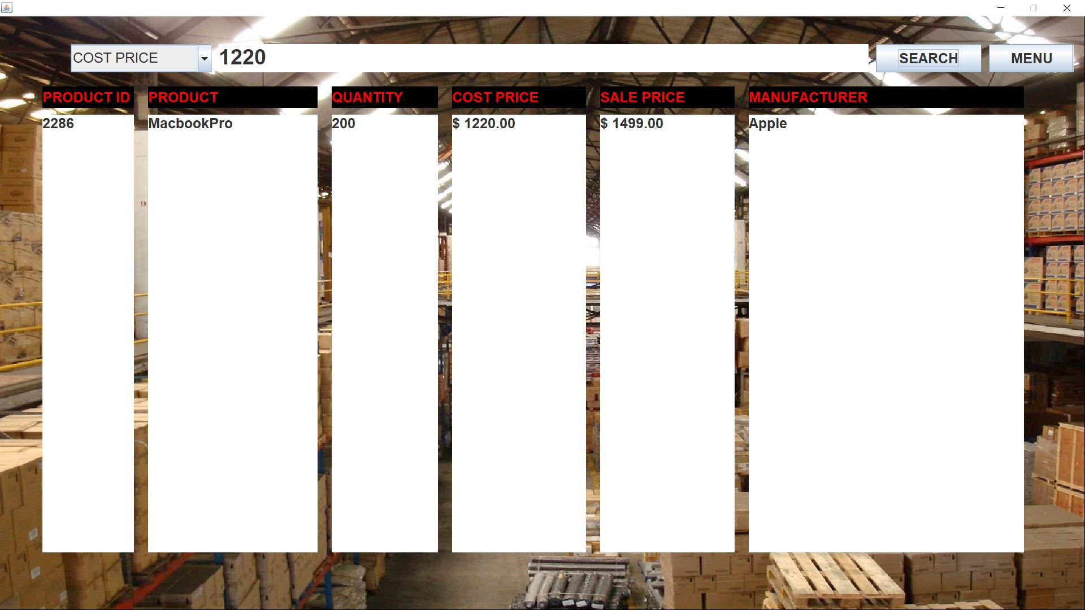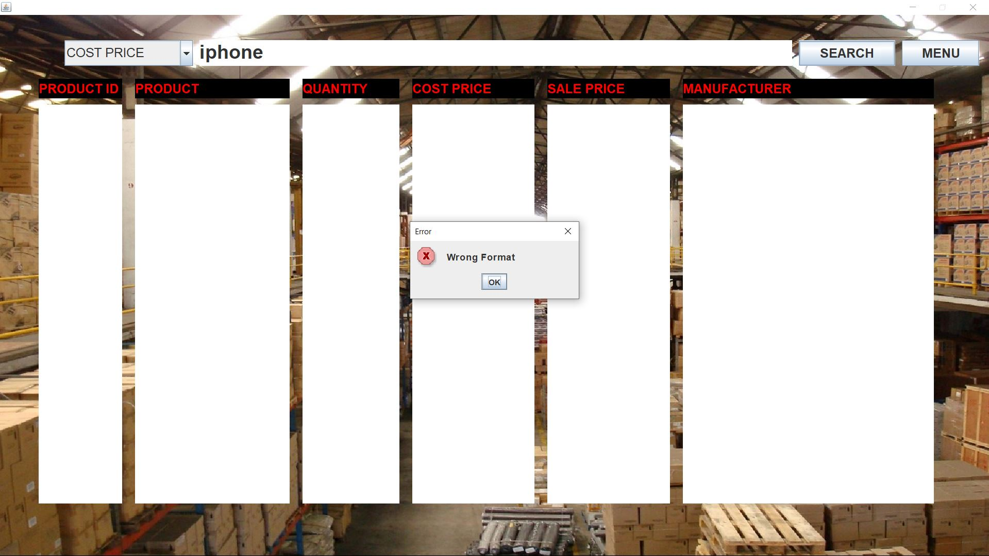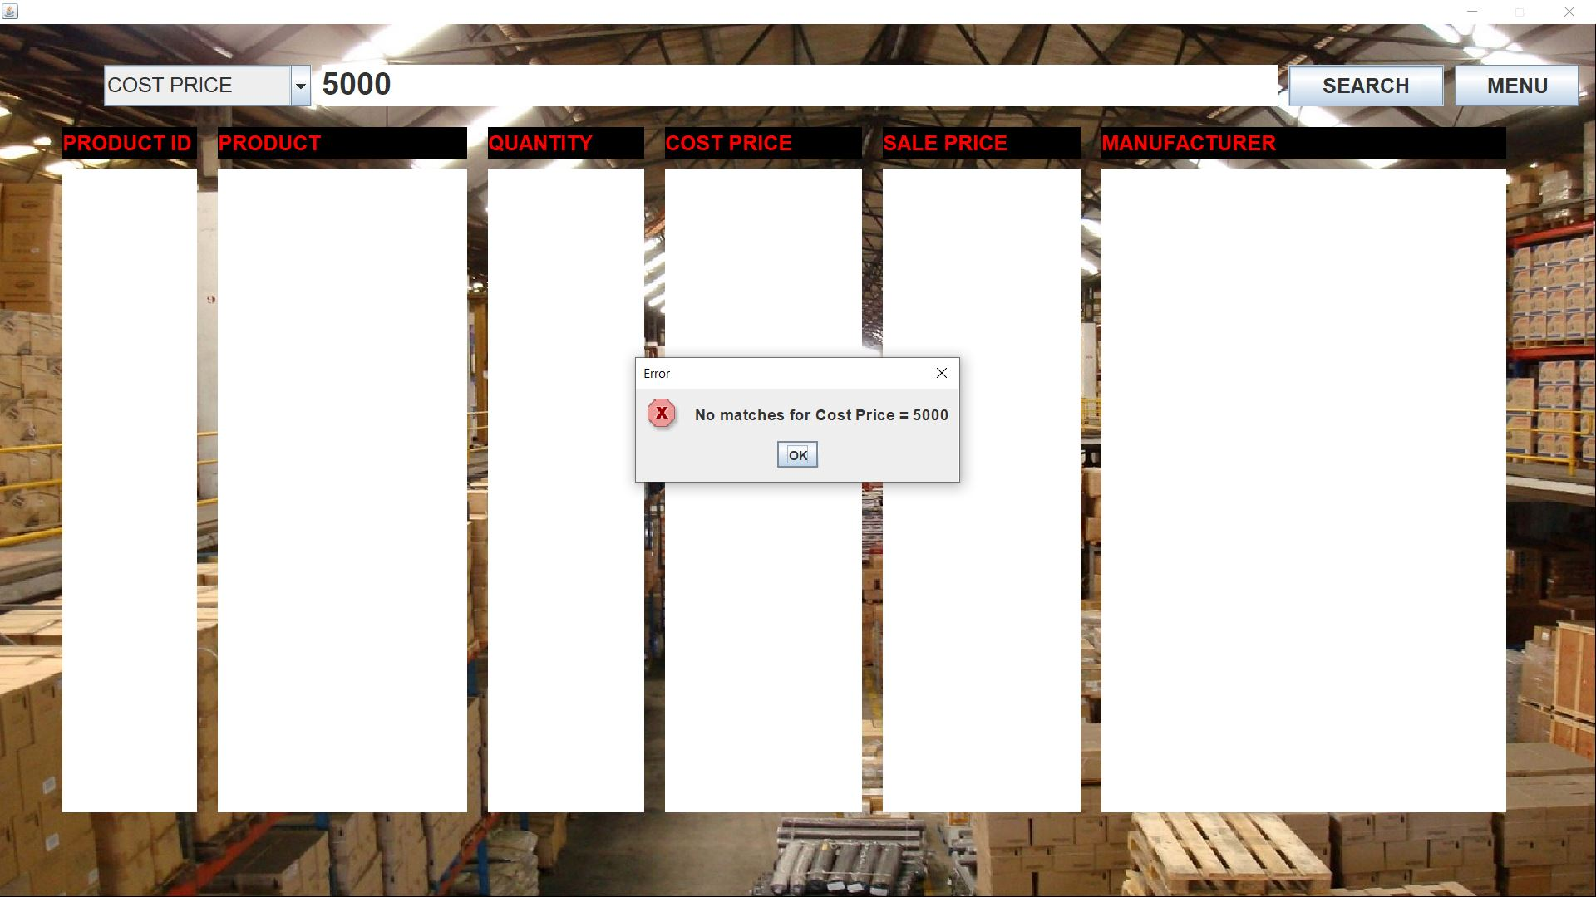

**UPDATE**

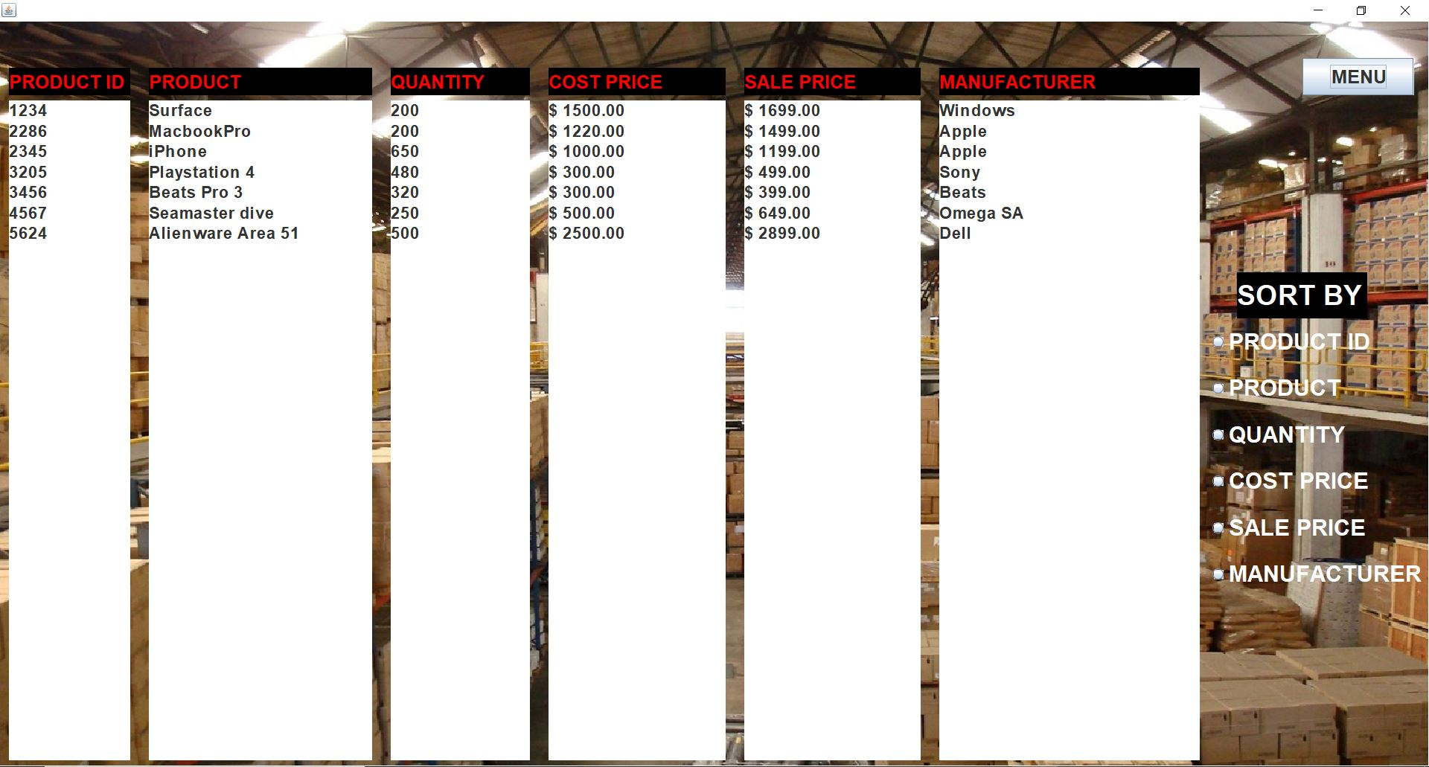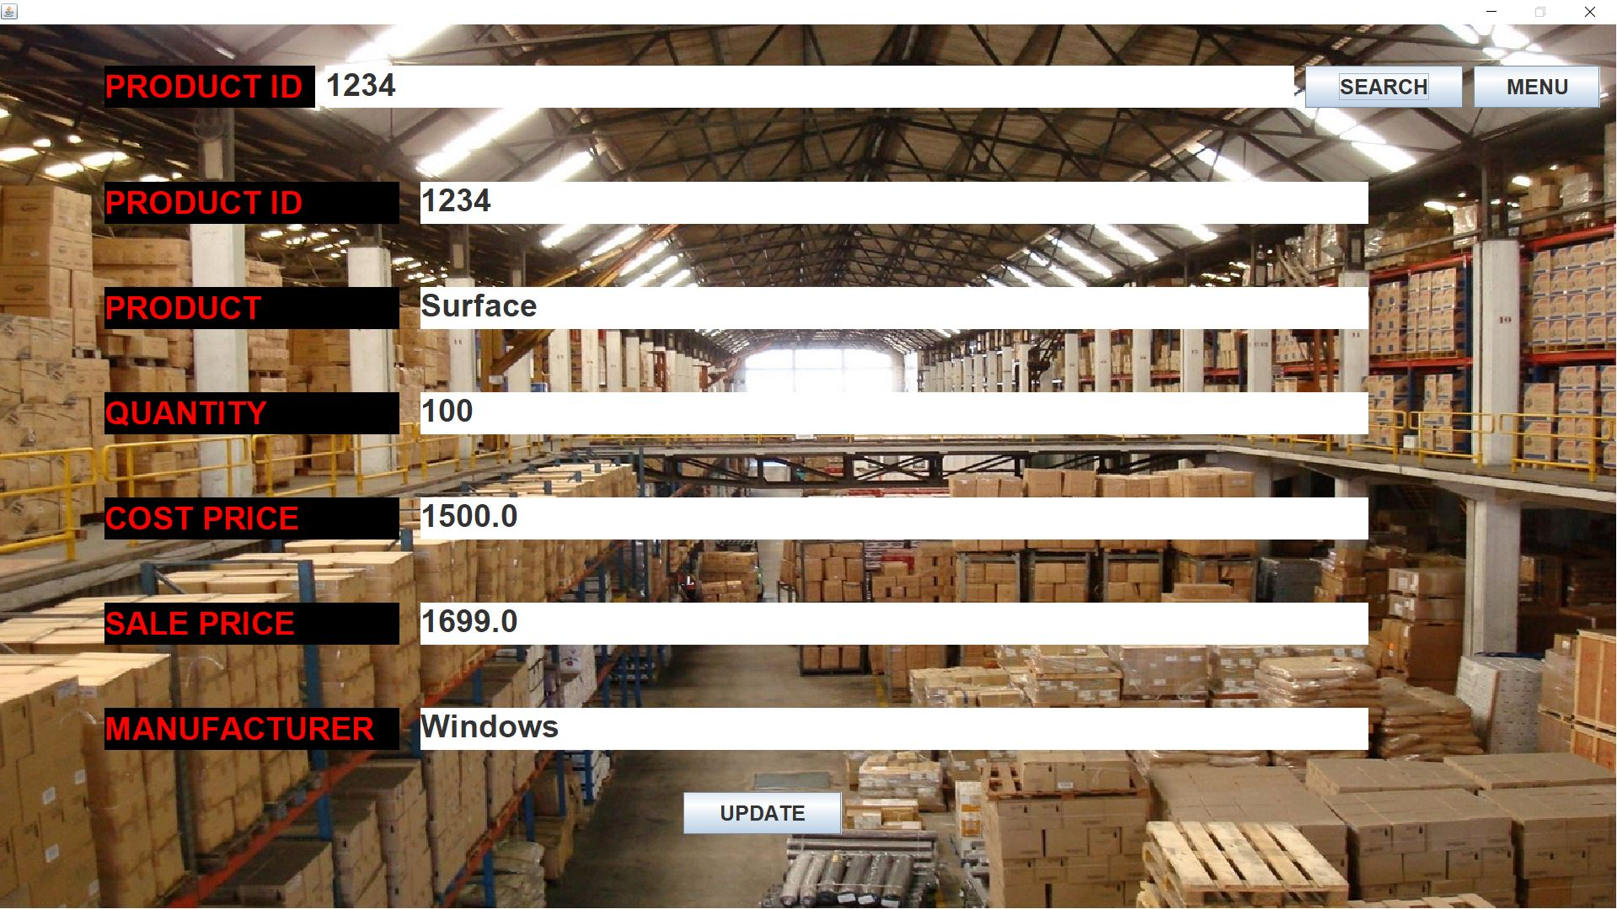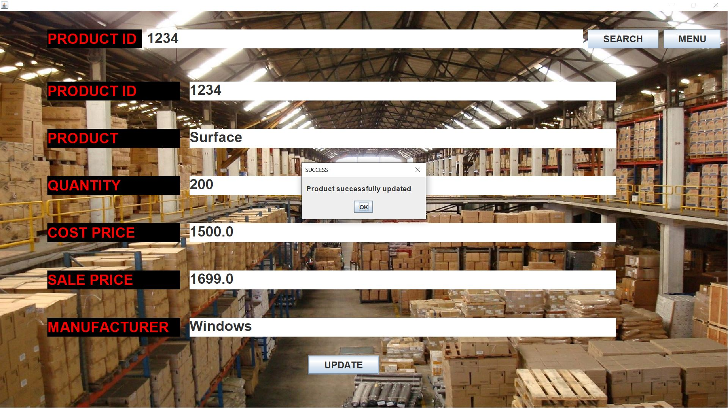

**VIEW**

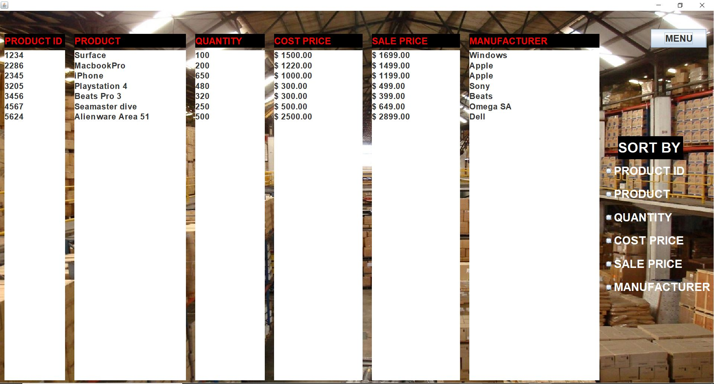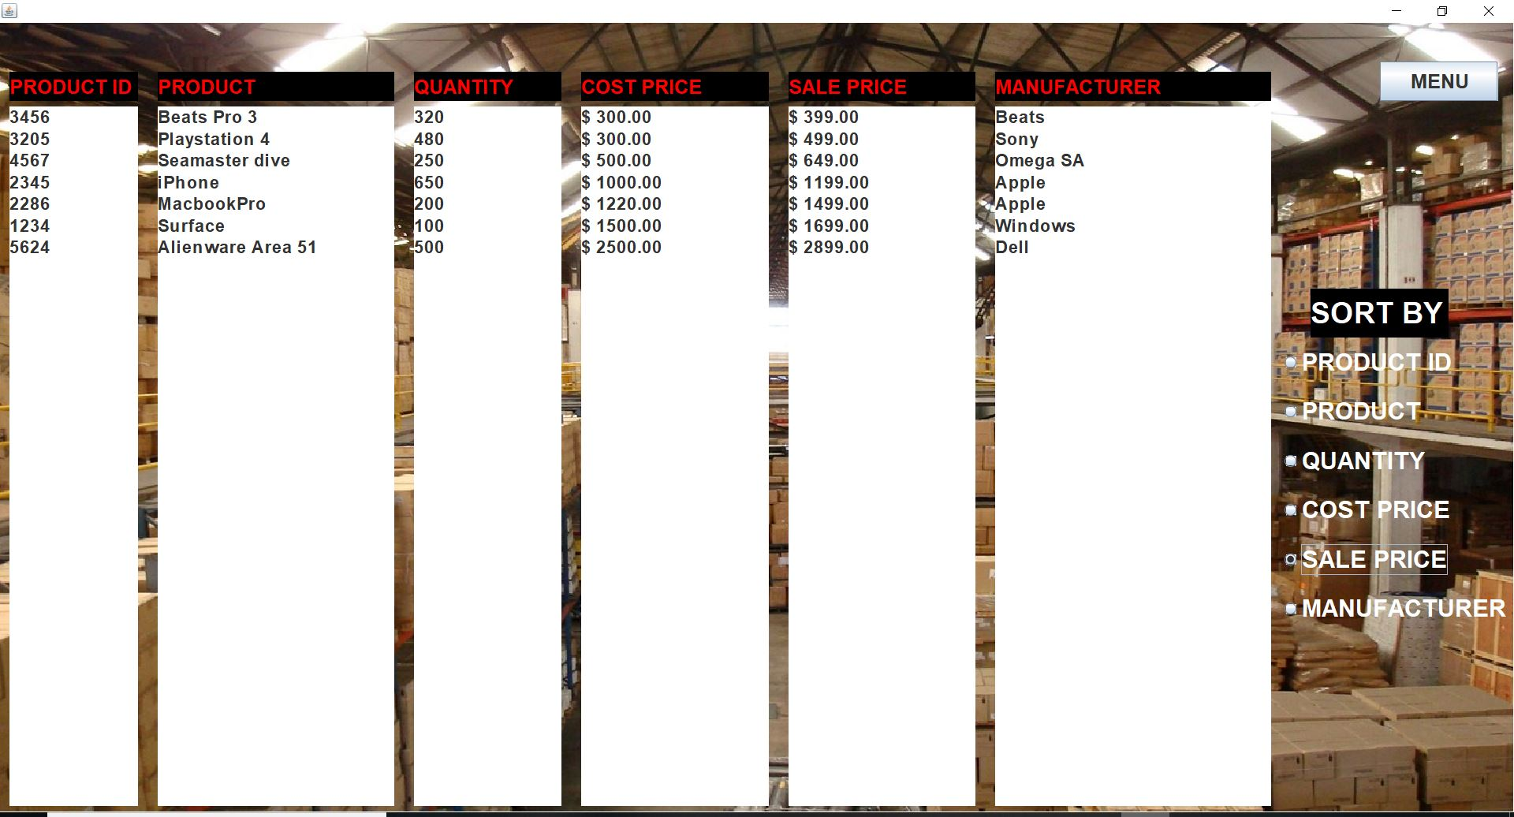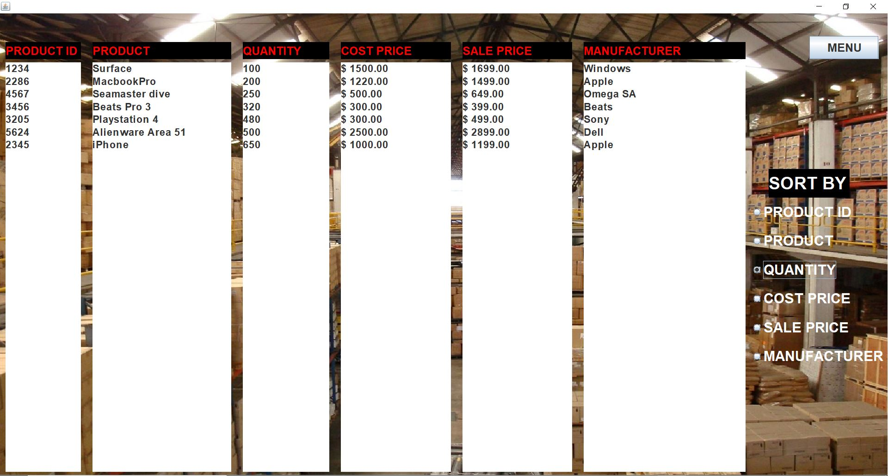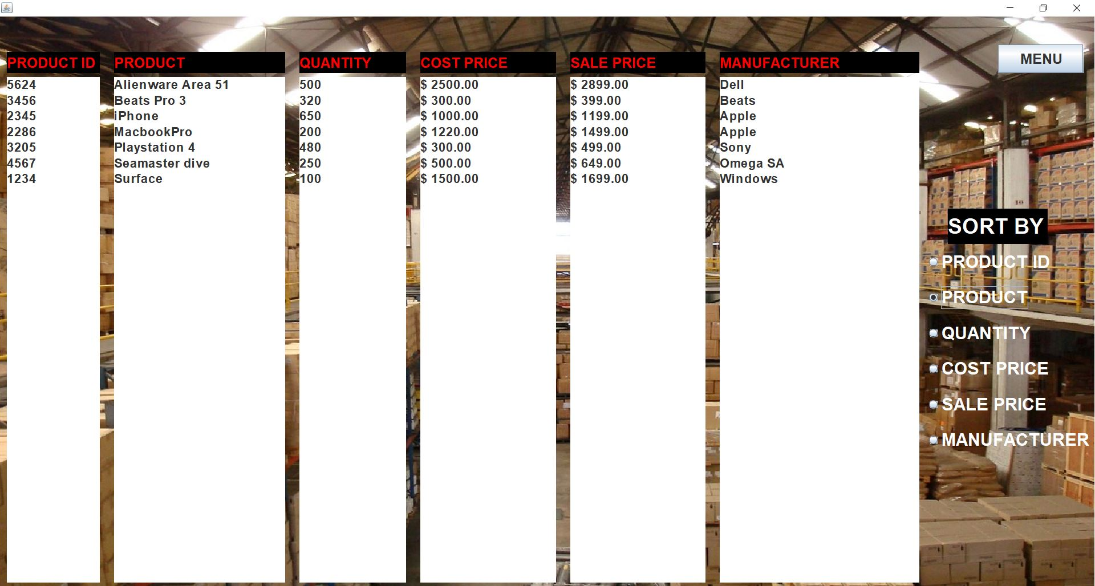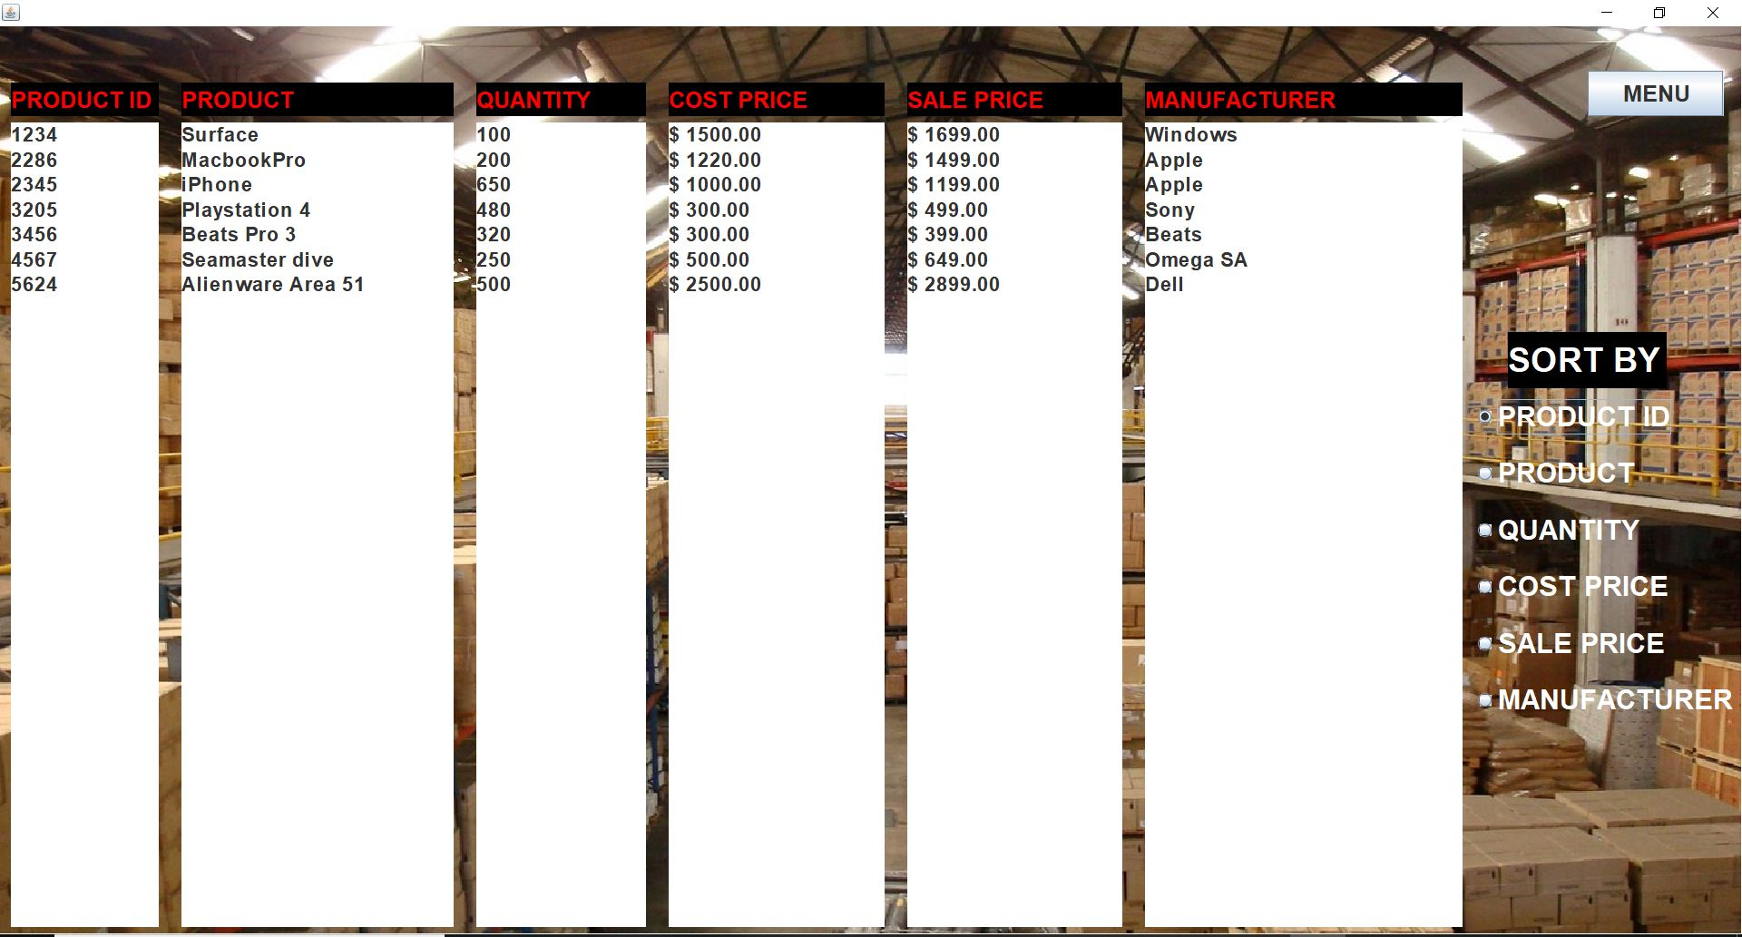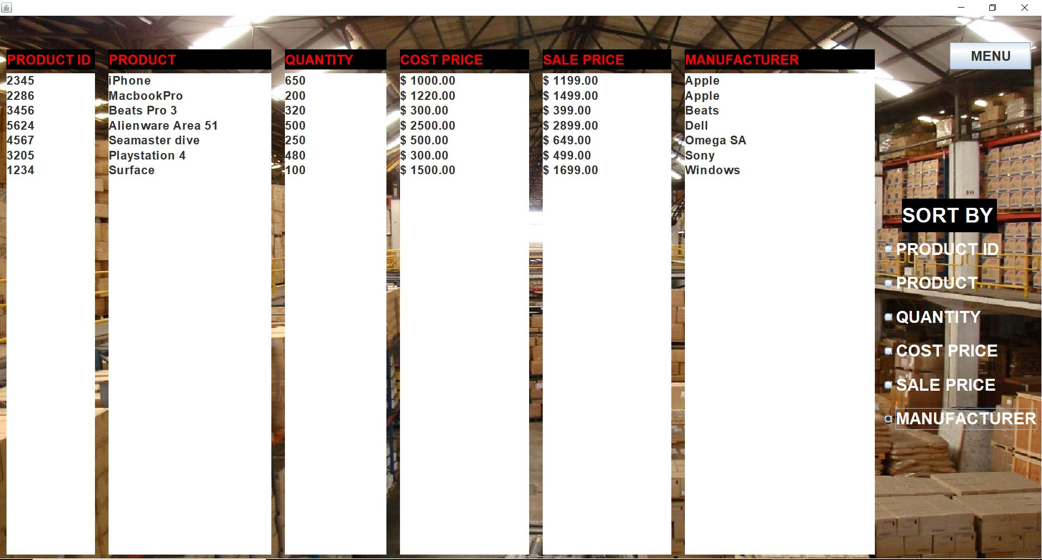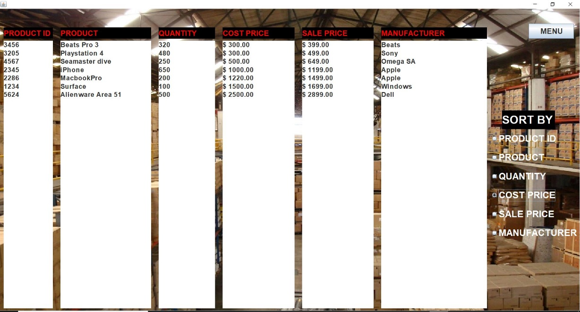

**i. Future Scope**

The company can add additional details about the products if required. We can extend our Inventory Management system for multiple locations and different branches